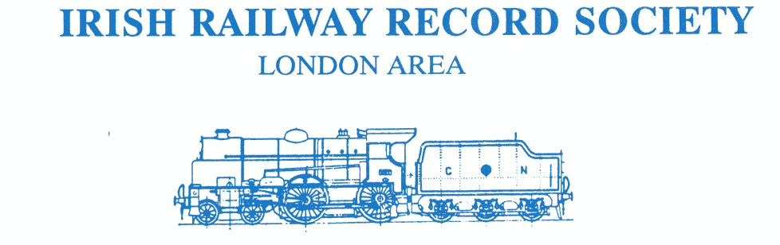
www.irrslondon.com irrslondon@hotmail.com

PROGRAMME 2021/22

The London Area of the IRRS provides a forum in South-East England for those interested in Irish transport, particularly railways, and arranges monthly speaker meetings during the winter. For
Oct-Apr, our meetings will be held online.

Those on the London Area e-mail list will be sent further details of all meetings. If you would like to be added to our e-mail list, please apply to irrslondon@hotmail.com . Please also check our website www.irrslondon.com for any updates to this programme.

ZOOM - Thursday 21 October 2021
“Irish Rail Timetabling – Slotting it all together” by Kieran Marshall
Kieran is an enthusiast, preservationist and railway professional working in Irish Rail’s timetabling office. Kieran describes how Irish Rail approaches the complex task of planning the timetable, balancing many different requirements between commercial, fleet, infrastructure and signalling, as well as personnel considerations. In addition to that, Kieran explains the further considerations involved in threading additional, special services through the timetable. It is challenging to “slot it all together” and Kieran gives us a close insight into the practicalities and professionalism involved.

ZOOM - Thursday 18 November 2021
“The County Donegal Railway – Survival and Revival” by Joe Begley
Joe is a railway author long interested in the CDR. Based on new material, he recounts the many challenges faced but survived by the railway – financial, Partition and war to name but three – enabling it to outlive most of its contemporaries until closure in 1959. But the story did not end there. Many items of rolling stock enjoyed a stay of execution and have been recovered and restored by the North West of Ireland Railway Society, the Foyle Valley Railway Centre and the South Donegal Railway Restoration Society. The memory of the CDR is secure and Joe brings the story right up to date.

ZOOM - Thursday 9 December 2021 “With Lance King in Ulster 1957 – 1970 - The NCC in Action”
by Leslie McAllister + London Area AGM
London Area Committee member, Leslie McAllister, pays a third tribute to our late founder Chairman, Lance King, Tonight, we enjoy Lance’s colour images of the remaining lines of the former Northern Counties Railway (the NCC) and the activities of its locomotives both on their home lines and on the Great Northern. Lance also photographed modern diesel units, so a period of change is faithfully recorded. Lance travelled on many of the early RPSI tours and the period concludes with the famous Stone Trains. A heady mixture of nostalgia, brilliantly recorded by a master photographer!
followed by the London Area AGM at 21.00

IRRS (London Area) 60th ANNIVERSARY CELEBRATION postponed
Our 60th anniversary celebration, planned for Saturday 6th November 2021 has been postponed due to Covid risks. It is now planned for the afternoon of Saturday 5th November 2022 in central London. Further details in a year’s time but please note the new date.

continued overleaf
www.irrslondon.com irrslondon@hotmail.com

PROGRAMME 2021/22 (continued)

Thursday 20 January 2022
“Irish Railway Catering 1900-2017 - From dining car to food trolley” by Louis Cullen
Louis Cullen, Fellow Emeritus in History at TCD, shares his research into railway catering in the Republic of Ireland. It started with meals from refreshment rooms in stations, onboard catering then expanded after 1918, the GSR’s Pullman cars followed, expansion continued and the zenith was reached in the “golden years” of the 1990’s, with over 70 trains/day offering catering cars including City Gold and the Enterprise. The service is now offered by private contractors (on and off trains) and by 2017 the onboard offer was largely a trolley service. One longs for the old buffet and dining cars.

Thursday 17 February 2022 “80 years of Bord na Mőna” by Andrew Waldron and Ted McAvoy
Andrew and Ted are BnM experts. As Ireland’s largest ng railway draws to a close, they present almost an insider’s review of the past 80 years from the earliest days at Clonsast to the last rites on the plains of Mayo, embracing infrastructure, rolling stock, day-to-day operations, engineering work, the last peat fired, steam driven briquette plant in the world etc.. But more than that, the two speakers knew the BnM staff, they understood the psyche of the railway, and they enjoyed many entertaining and hilarious experiences on their frequent visits. You won’t get a better insight to BnM.

Thursday 17 March 2022 “50 years ago – the films of Macha Film Studios” by John Friel
John Friel, brother Charles and others set up Macha Film Studios in the late-1960’s to record the disappearance of steam and other traditional features of the Irish railway scene. Although amateurs, their approach to film making was highly professional embracing a filming van, imaginatively planned and co-ordinated shots, different photographers at different places, and skilful editing afterwards. Their results are among the best of Irish railway ciné. Hear how they did it and enjoy the sights and sounds of steam on the GN, early RPSI tours, spoil trains, goods trains on the Burma Road etc..

Thursday 21 April 2022 “NIR - Today and Tomorrow” by Richard Knox
Richard Knox, General Manager NIR Rail Services, brings us up-to-date with how the company is performing and developing. He will explain where the company stood pre-Covid, developments at the time, the impact of Covid, and will give us an insight to the future. Exciting developments are in the pipeline such as the New Trains programme to create permanent 6-car CAF units, station developments including the Belfast Transport Hub, track and signalling upgrades and, further ahead, plans to upgrade the Enterprise service and to reduce NIR's carbon emissions.

SALES STANDS cancelled
The usual IRRS sales stands at the Warley National Model Railway Exhibition and
at SCALEFORUM and SCALEFOUR NORTH have been cancelled this season due to Covid risks.

TRANSPORT COLLECTORS’ MARKET cancelled
Our TCM planned for March 2022 has been cancelled due to Covid risks.
It is planned to hold our next TCM in March 2023.

